Risk Metrics
Drawdown, Risk-Adjusted Ratios, Trade Statistics, Value at Risk & Expected Shortfall, and the Taxonomy of Portfolio Risk
Quantifying How Risky a Strategy or Portfolio Really Is
A Level 2 module in the Quantitative Finance Curriculum — revisited at Level 5
Covers: Drawdown · Sharpe/Sortino/Calmar ratios · profit factor · win rate · expectancy · Value at Risk · Expected Shortfall · stress testing/scenario analysis · factor/concentration/liquidity/leverage/counterparty/model risk

Table of Contents
How to Use This Guide
What You Need to Know Before Starting
Understand Before Proceeding
Why It Matters
How This Connects to the Rest of the Curriculum
Glossary of Recurring Terms
Part 1 — Drawdown: The Path-Dependent Risk Measure
1.1 Maximum Drawdown
1.2 Drawdown Duration and the Underwater Curve
Part 2 — Risk-Adjusted Return Ratios
2.1 The Sharpe Ratio
2.2 The Sortino Ratio
2.3 The Calmar Ratio
Part 3 — Trade-Level Metrics
3.1 Profit Factor
3.2 Win Rate
3.3 Expectancy
Part 4 — Tail Risk: Value at Risk and Expected Shortfall
4.1 Value at Risk (VaR)
4.2 Expected Shortfall (CVaR)
Part 5 — Stress Testing and the Taxonomy of Portfolio Risk (Awareness Level)
5.1 Stress Testing and Scenario Analysis
5.2 Factor, Concentration, Liquidity, Leverage, Counterparty, and Model Risk
Practical Exercise
Common Beginner Mistakes
Advanced Extensions
Professional Applications
Where to Go Next

How to Use This Guide
This document is a companion to Risk Metrics, the second-level module in the quantitative finance curriculum that is revisited in more depth at Level 5. It covers the standard vocabulary and formulas used to quantify how risky a strategy or portfolio is — the numbers that ultimately determine whether a strategy gets capital, and whether it keeps it.
The module is self-contained: every metric is introduced from first principles, paired with a short runnable Python sketch, and illustrated with a chart wherever a picture makes the idea land faster than a formula. Read it start to finish if risk metrics are new to you, or jump straight to the section you need.

What You Need to Know Before Starting
- Returns & Portfolio Mathematics — how simple and log returns are computed, compounded, and annualized, since every metric in this module is built on top of a return series.
- Statistics — mean, variance, standard deviation, percentiles, and basic hypothesis-testing intuition, reused throughout in the discussion of sampling error.
- Volatility Modelling — how volatility is estimated and why it clusters and changes over time, since almost every ratio in this module divides by some estimate of volatility.

Understand Before Proceeding
Prerequisite gate — Do not report or compare Sharpe ratios without understanding the sample size and volatility-estimation error behind them. A Sharpe ratio computed on a short or unstable sample is an estimate with a wide error band, not a fixed fact about a strategy — treating it as the latter is one of the most common and most consequential mistakes in strategy evaluation.

Why It Matters
Every trading and investment decision is ultimately a trade-off between return and risk, and risk metrics are the vocabulary that trade-off is negotiated in. A strategy with an excellent average return but an unmeasured or misunderstood risk profile is not a known quantity — it is a bet on numbers nobody has actually looked at. Risk metrics are frequently misinterpreted: a Sharpe ratio without its sample size, a VaR figure treated as a worst-case loss, or a win rate quoted without the size of the wins and losses behind it, can each make a strategy look safer or more skillful than it is. Getting the vocabulary and its caveats right is what separates a rigorous evaluation from a misleading one.

How This Connects to the Rest of the Curriculum
- Research — Risk metrics are the primary output of the validation stage of the research lifecycle — the numbers a strategy must clear before it is taken seriously, and the numbers that get revisited if live performance diverges from backtest.
- Development — Risk-metric calculation must be centralised and tested — divergent Sharpe or drawdown calculations across notebooks (different annualisation conventions, different handling of missing days) are a common, avoidable source of confusion and of researchers unknowingly comparing incomparable numbers.
- Trading — VaR and Expected Shortfall drive real-time risk limits and margin requirements — these are not backward-looking report metrics only, they are live constraints that can force position reductions the moment they are breached.

Glossary of Recurring Terms
Drawdown — The decline in an equity curve from a previous peak (high-water mark) to a subsequent trough, expressed as a percentage — the standard measure of path-dependent, realized pain in a strategy's history.
Maximum drawdown (MDD) — The single largest peak-to-trough decline observed over a given period — the worst point an investor holding the strategy would actually have experienced.
Sharpe ratio — Excess return over the risk-free rate, divided by the total standard deviation of returns — the most widely quoted risk-adjusted return measure, and the most widely misused.
Sortino ratio — Like the Sharpe ratio, but the denominator is downside deviation (volatility of returns below a minimum acceptable return) rather than total volatility — a measure that does not penalize upside volatility.
Calmar ratio — Annualized return divided by maximum drawdown — a risk-adjusted measure that uses a path-dependent, worst-case risk figure in its denominator rather than a volatility estimate.
Profit factor — Gross profit divided by gross loss across a set of trades — a factor above 1 indicates a net-profitable system before considering the distribution of individual trade outcomes.
Win rate — The fraction of trades that are profitable — informative only in combination with the relative size of average wins and average losses, never on its own.
Expectancy — The average profit or loss per trade, computed as (win rate × average win) + (loss rate × average loss) — the single number that answers whether a trading system is profitable on average, independent of win rate alone.
Value at Risk (VaR) — A threshold loss value such that losses worse than it occur with only a specified probability (e.g., 5%) over a given horizon — a quantile of the loss distribution, not a bound on the worst possible loss.
Expected Shortfall (ES / CVaR) — The average loss in the scenarios where losses exceed the VaR threshold — a measure of the severity of the tail that VaR, by construction, does not capture.
Stress testing / scenario analysis — The practice of evaluating portfolio performance under hypothetical or historically-replayed extreme scenarios, rather than relying solely on statistical loss estimates calibrated to normal market conditions.
Factor risk — Exposure to broad, systematic drivers of return (market, value, momentum, rates, etc.) that move many positions together, rather than risk specific to any single position.
Concentration risk — The risk arising from a portfolio's exposure being unusually concentrated in a small number of positions, sectors, or factors, rather than diversified across many independent sources of return.
Liquidity risk — The risk that a position cannot be exited (or can only be exited at a much worse price) within the time frame needed, particularly during stressed markets when liquidity itself tends to evaporate.
Leverage risk — The risk that borrowed capital or derivatives exposure amplifies losses (and margin calls) beyond what the underlying capital base can absorb.
Counterparty risk — The risk that the other side of a trade or agreement (a broker, a clearinghouse, an OTC counterparty) fails to meet its obligations.
Model risk — The risk that a pricing, risk, or trading model is wrong, misapplied, or used outside the conditions under which it was validated — a risk about the tools used to measure and manage all the other risks.

Part 1 — Drawdown: The Path-Dependent Risk Measure
Every other metric in this module describes a return series in the abstract — its average, its spread, its tail. Drawdown is different: it is read directly off the equity curve, and it is the number that corresponds most directly to what an investor actually lives through while holding a strategy. This part defines maximum drawdown and the underwater curve used to visualize it.

1.1 Maximum Drawdown
Drawdown at any point in time is the percentage decline from the running peak (high-water mark) of the equity curve to the current value:
Drawdown(t) = (Equity(t) − RunningMax(Equity, 0..t)) / RunningMax(Equity, 0..t)
Maximum drawdown (MDD) is simply the most negative value this quantity takes over the period examined — the single worst peak-to-trough decline in the strategy's history. Because it is computed from the cumulative equity curve rather than from individual returns, drawdown is inherently path-dependent: two strategies with identical average return and identical volatility can have very different maximum drawdowns depending on the order in which gains and losses occurred, and specifically on how much of the losing period is clustered together.
Tip — Drawdown is always measured relative to a prior peak, not relative to a starting value. A strategy that is up 40% and then falls back to being up 20% has experienced a drawdown even though it remains profitable overall — the high-water mark, not the starting capital, is the reference point.

1.2 Drawdown Duration and the Underwater Curve
Depth (maximum drawdown) is only half the picture. Drawdown duration — how long the equity curve stays below a prior peak before making a new high — matters just as much in practice, since a strategy that spends years underwater is far harder to hold, from both a psychological and a capital-allocation standpoint, than one that recovers quickly even if the two have identical maximum depth. The underwater curve (plotting drawdown against time) is the standard way to visualize both dimensions simultaneously.
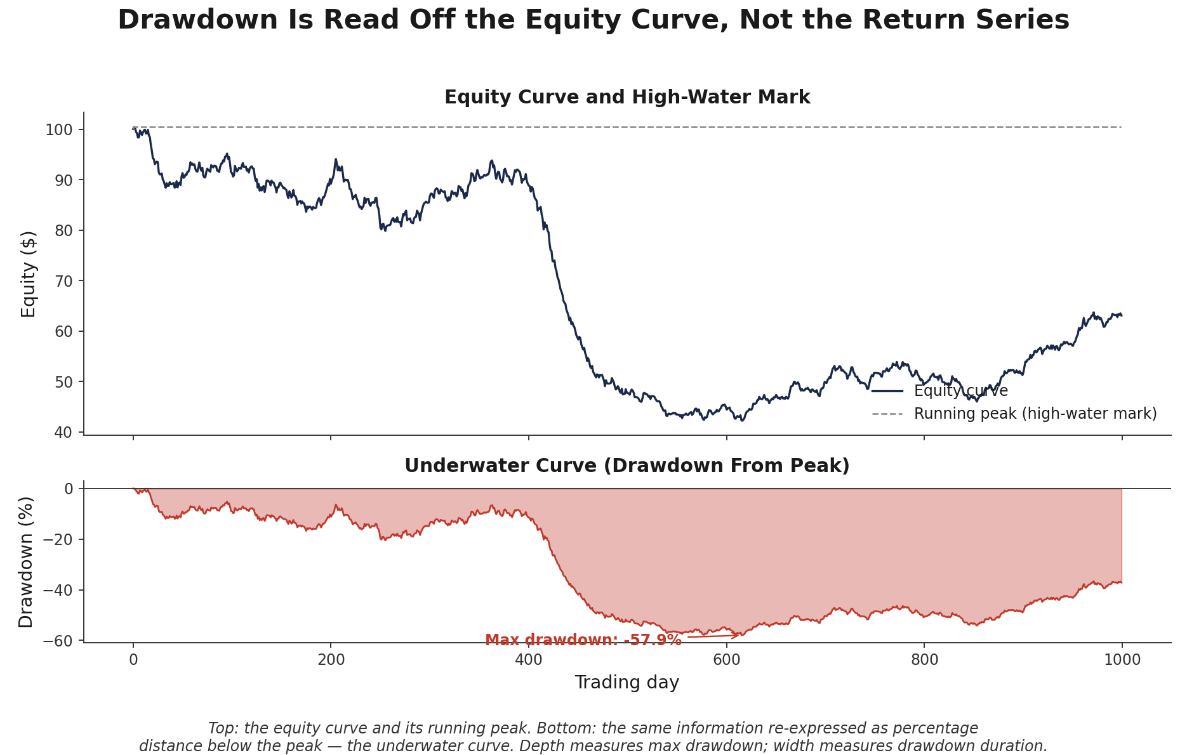
Figure 1.1 — Top: the equity curve and its running peak (high-water mark). Bottom: the same information re-expressed as the underwater curve — percentage distance below the peak. The depth of the trough is the maximum drawdown; its width is the drawdown duration.
equity = 100 * (1 + returns).cumprod()
running_max = equity.cummax()
drawdown = (equity - running_max) / running_max

max_drawdown = drawdown.min() # depth
underwater = drawdown < 0
# longest consecutive run of `underwater` == longest drawdown duration

Part 2 — Risk-Adjusted Return Ratios
Raw return tells you how much a strategy made. It says nothing about how much risk was taken to make it — and two strategies with identical returns but very different risk profiles are not equally good. This part covers the three standard ratios used to adjust return for risk, each dividing by a different notion of what 'risk' means: total volatility (Sharpe), downside volatility only (Sortino), or worst-case realized loss (Calmar).

2.1 The Sharpe Ratio
The Sharpe ratio divides a strategy's excess return over the risk-free rate by the standard deviation of its returns:
Sharpe = (R̄ₚ − Rf) / σₚ (commonly annualized: Sharpe_annual = Sharpe_period × √(periods per year))
Intuitively, the Sharpe ratio asks: how much return did this strategy generate per unit of total volatility endured? A higher Sharpe ratio means more return for the same volatility, or the same return for less volatility. Its central weakness is exactly what makes it simple: total standard deviation penalizes upside volatility (large, welcome gains) exactly as harshly as downside volatility (losses), which can make a strategy with an occasional large winning streak look artificially more 'risky' than one with a smooth, mediocre return profile.
The more consequential issue in practice is sampling error. A Sharpe ratio is an estimate computed from a finite sample of returns, and with a short sample, that estimate carries a wide error band around the true (unknown) Sharpe ratio of the underlying process.
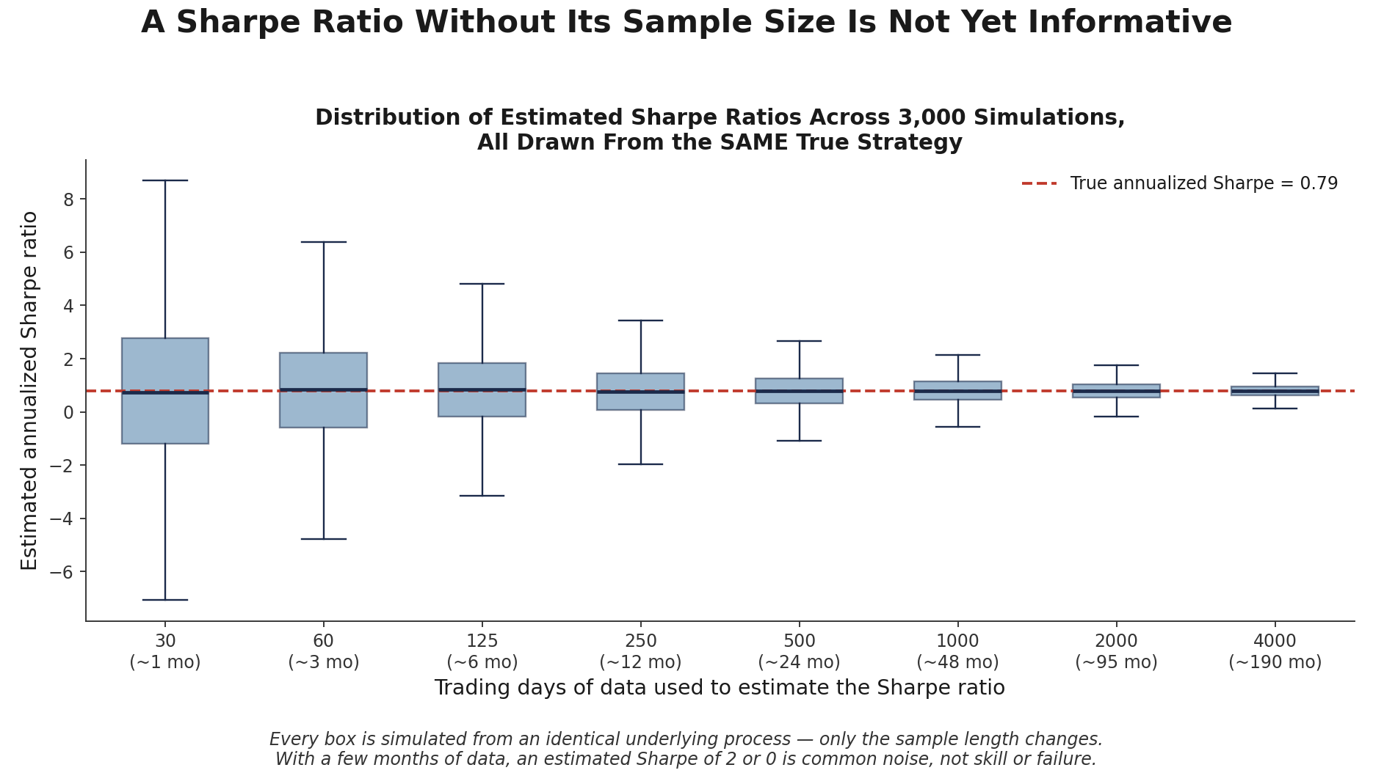
Figure 2.1 — 3,000 simulated Sharpe-ratio estimates, all drawn from the identical underlying process, at increasing sample lengths. With a few months of data an estimated Sharpe of 2 (or of 0) is common statistical noise, not evidence of skill or of failure — only at several years of data does the estimate reliably converge near the true value.
Common mistake — Reporting a Sharpe ratio without stating the annualisation convention or the sample size behind it. A Sharpe ratio computed on 3 months of daily data and one computed on 5 years of daily data are not comparable even if both are annualized identically — the first carries a far wider confidence interval, and treating the two point estimates as equally reliable is a direct route to over-allocating capital to a strategy that simply got lucky.

import numpy as np

excess = returns - risk_free_rate_per_period
sharpe = excess.mean() / returns.std(ddof=1)
sharpe_annualized = sharpe * np.sqrt(252) # 252 for daily data

2.2 The Sortino Ratio
The Sortino ratio uses the same numerator as the Sharpe ratio but replaces total standard deviation with downside deviation — the standard deviation computed using only returns that fall below a minimum acceptable return (MAR), often zero:
Sortino = (R̄ₚ − MAR) / σ_downside, where σ_downside² = mean[min(Rₜ − MAR, 0)²]
Because upside volatility is excluded from the denominator entirely, the Sortino ratio does not penalize a strategy for having occasional large gains — it isolates the specific kind of volatility that investors actually experience as risk. Two strategies with identical Sharpe ratios can have meaningfully different Sortino ratios if one has a more asymmetric (positively skewed) return distribution than the other.
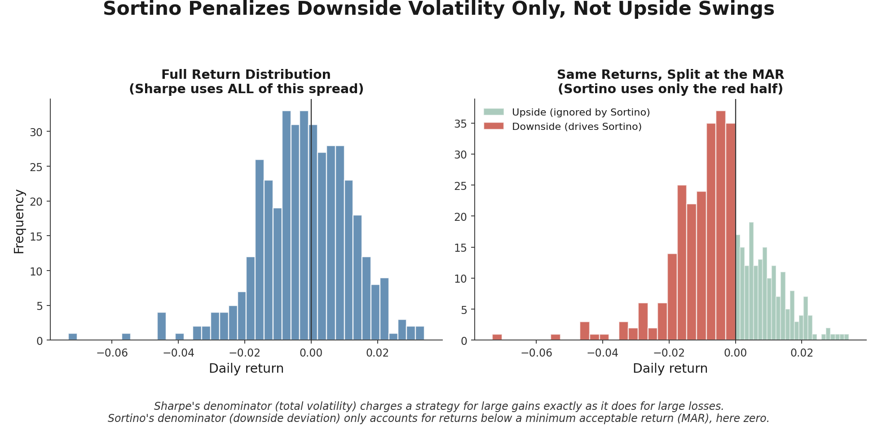
Figure 2.2 — Left: the full return distribution, all of which feeds into the Sharpe ratio's denominator. Right: the same returns split at the minimum acceptable return — only the shaded downside half (red) drives the Sortino ratio's denominator; the upside half (green) is ignored entirely.
mar = 0.0
downside_returns = returns[returns < mar]
downside_deviation = np.sqrt((downside_returns ** 2).mean())

sortino = (returns.mean() - mar) / downside_deviation
sortino_annualized = sortino * np.sqrt(252)

2.3 The Calmar Ratio
The Calmar ratio divides annualized return by maximum drawdown (from Section 1.1), rather than by any volatility estimate at all:
Calmar = Annualized Return / |Maximum Drawdown|
Because its denominator is a single worst-case, path-dependent realized figure rather than a statistical dispersion measure, the Calmar ratio answers a different question from Sharpe or Sortino: not 'how much return per unit of typical volatility' but 'how much return per unit of worst pain actually endured.' This makes it a natural complement to the other two ratios rather than a replacement — it is also more sensitive to the specific sample period examined, since a single bad month can dominate the denominator entirely.
annualized_return = (1 + total_return) ** (252 / n_days) - 1
calmar = annualized_return / abs(max_drawdown)

Part 3 — Trade-Level Metrics: Profit Factor, Win Rate, and Expectancy
The ratios in Part 2 are computed from a return series sampled at fixed intervals (daily, monthly). Trade-level metrics instead look at each individual trade a strategy generates — a natural complement for discretionary or signal-driven strategies where the trade, not the trading day, is the more meaningful unit of analysis.

3.1 Profit Factor
Profit factor is the ratio of gross profit to gross loss across a set of trades:
Profit Factor = Σ(profitable trade P&L) / |Σ(losing trade P&L)|
A profit factor above 1 indicates the system made more, in total, from its winners than it lost from its losers; below 1 indicates the reverse. Profit factor says nothing on its own about consistency or the distribution of outcomes — a profit factor of 1.5 built from one enormous winning trade and many small losers behaves very differently, and carries very different risk of ruin, from the same profit factor built from many similarly-sized wins and losses.

3.2 Win Rate
Win rate is simply the fraction of trades that are profitable:
Win Rate = Number of winning trades / Total number of trades
Win rate is the most quoted and most misleading trade statistic in isolation. A system can be highly profitable with a win rate well under 50% (many small, controlled losses offset by occasional large wins — the classic trend-following profile), and a system can be reliably unprofitable with a win rate well above 50% (frequent small wins wiped out by rare, large losses — the classic 'picking up pennies in front of a steamroller' profile). Win rate only becomes informative once combined with the relative size of wins and losses, which is exactly what expectancy does next.

3.3 Expectancy
Expectancy is the average profit or loss per trade, combining win rate with the average size of wins and losses into a single number:
Expectancy = (Win Rate × Average Win) + (Loss Rate × Average Loss)
Expectancy answers the question win rate and profit factor each answer only partially: on average, is each trade this system takes worth taking? A positive expectancy with a low win rate is a perfectly viable — even common — profile for a well-designed system, provided position sizing is disciplined enough to survive the losing streaks such a profile inevitably produces.
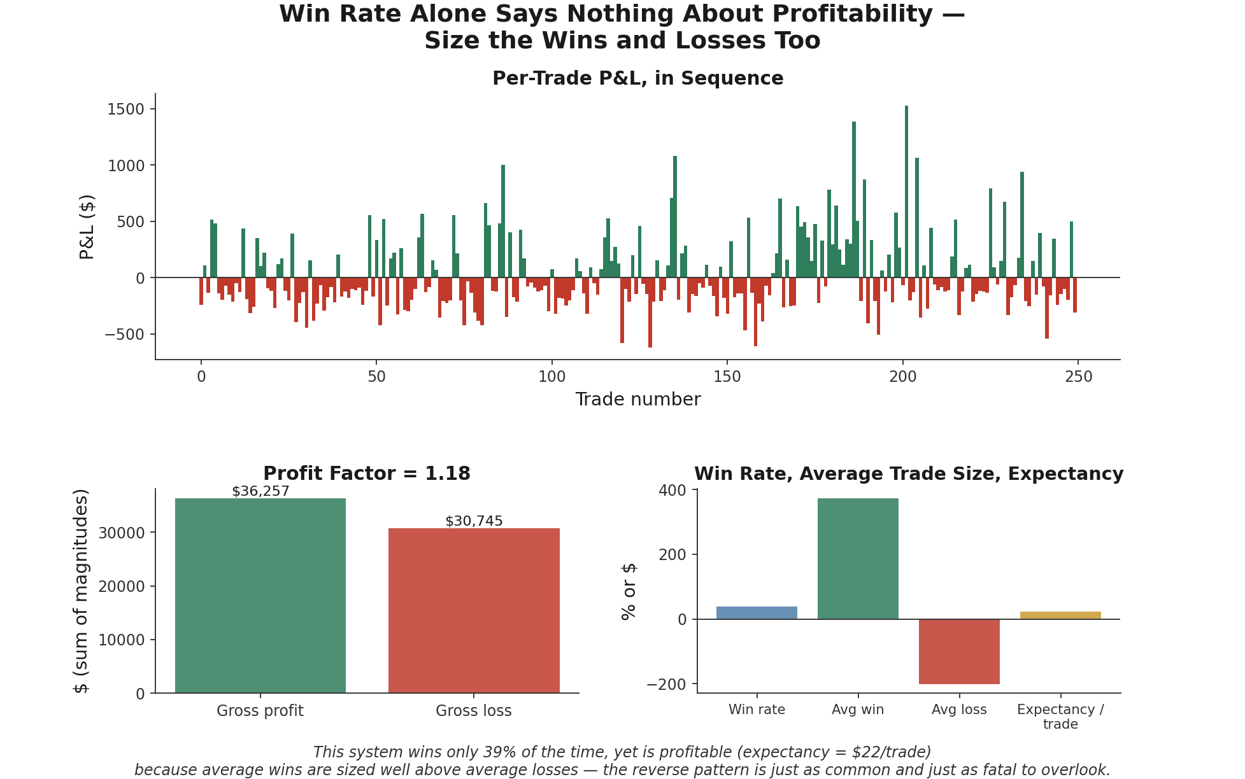
Figure 3.1 — A simulated 250-trade system with a win rate of only 39% is nonetheless profitable, because average wins are sized well above average losses, giving a profit factor above 1 and positive expectancy per trade. The reverse pattern — a high win rate with a negative expectancy — is just as common and just as easy to overlook without computing expectancy explicitly.
wins = trade_pnl[trade_pnl > 0]
losses = trade_pnl[trade_pnl < 0]

profit_factor = wins.sum() / abs(losses.sum())
win_rate = len(wins) / len(trade_pnl)
expectancy = win_rate * wins.mean() + (1 - win_rate) * losses.mean()

Part 4 — Tail Risk: Value at Risk and Expected Shortfall
The metrics so far describe typical or worst-observed behaviour. Value at Risk and Expected Shortfall instead describe the shape of the loss distribution's tail directly — the region that matters most for capital adequacy, margin requirements, and the kind of loss a portfolio needs to be able to survive, not merely endure.

4.1 Value at Risk (VaR)
Value at Risk at confidence level (1 − α) is the threshold loss such that losses worse than it occur with probability α over a given horizon. Historical VaR — the most common and most transparent approach — simply reads this threshold off the empirical distribution of past returns:
VaR_α = −Percentile(returns, α) (e.g., α = 5% for 95% VaR)
Parametric VaR instead assumes a distribution (commonly Normal) for returns and computes the corresponding quantile analytically; it is faster to compute and smoother, but understates tail risk whenever real returns are more fat-tailed than the assumed distribution — which, for most financial return series, they are.
Common mistake — Treating VaR as a worst-case loss. VaR is a quantile — a threshold that losses exceed with a known, non-zero probability — not a bound on how bad a loss can get. A 95% VaR of 2% guarantees nothing about the size of a loss on one of the 5% of days that breach it; that loss could be 2.1% or 12%, and VaR alone cannot distinguish between those two very different worlds. Section 4.2's Expected Shortfall exists specifically to answer the question VaR leaves open.

4.2 Expected Shortfall (CVaR)
Expected Shortfall (also called Conditional VaR) is the average loss across exactly the scenarios VaR is silent about — the mean loss conditional on the loss already exceeding the VaR threshold:
ES_α = E[Loss | Loss > VaR_α]
Where VaR marks where the tail begins, Expected Shortfall measures what the tail actually looks like once you're in it. Because it averages over the full severity of tail outcomes rather than reporting a single threshold, Expected Shortfall is generally considered the more informative — and, since the 2019 Basel market-risk framework, the regulatory-preferred — tail-risk measure for market risk capital.
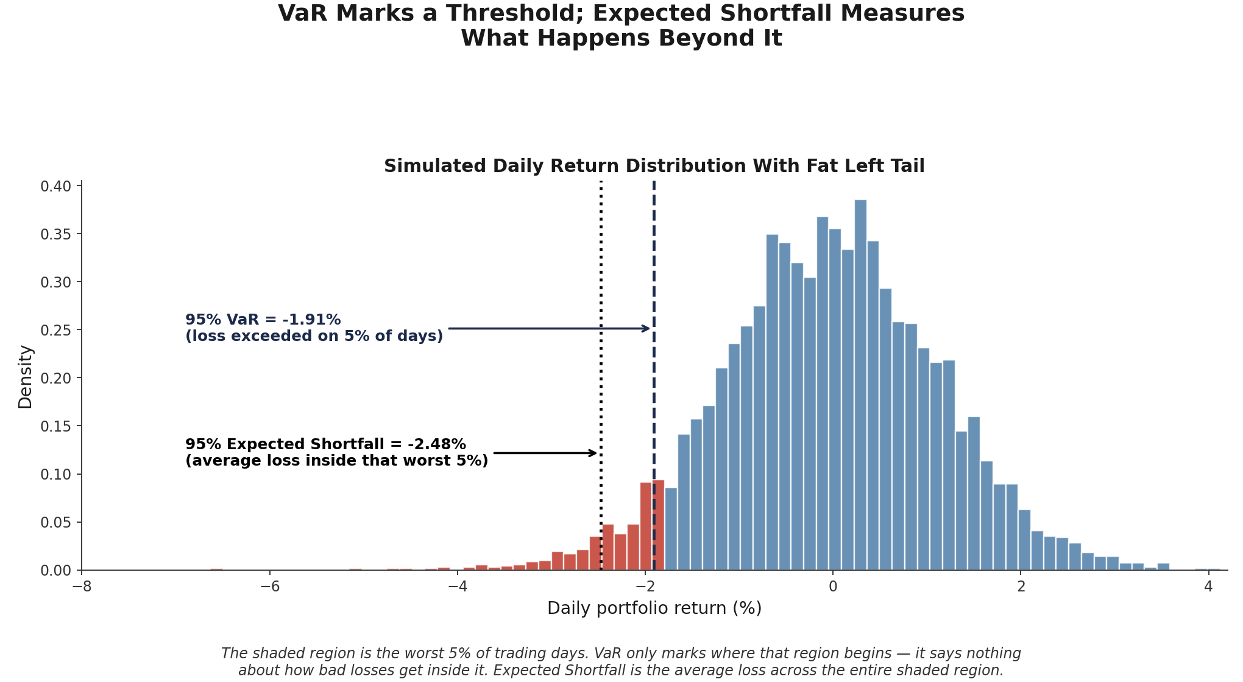
Figure 4.1 — A simulated daily return distribution with a fat left tail. The shaded region is the worst 5% of trading days. The 95% VaR (dashed line) only marks where that region begins; the 95% Expected Shortfall (dotted line) is the average loss across the entire shaded region — visibly worse than VaR alone would suggest.
alpha = 0.05
var_95 = -np.percentile(returns, alpha * 100)

tail_losses = returns[returns <= -var_95]
es_95 = -tail_losses.mean() # average loss inside the worst 5% of days

Part 5 — Stress Testing and the Taxonomy of Portfolio Risk (Awareness Level)
VaR and Expected Shortfall are both calibrated to the statistical behaviour of historical returns — which means both are, by construction, blind to genuinely novel scenarios that have no close historical analogue in the sample used to estimate them. This part introduces stress testing as the complementary tool for exactly that gap, and surveys — at an awareness level, to be developed fully at later stages of the curriculum — the broader taxonomy of portfolio risk beyond price-return volatility alone.

5.1 Stress Testing and Scenario Analysis
Stress testing applies a hypothetical or historically-replayed extreme scenario directly to a current portfolio's positions, rather than inferring a loss threshold from the statistical properties of past returns. Historical scenarios replay an actual past crisis (a 2008-style credit event, a 2020-style liquidity shock) against today's holdings; hypothetical scenarios construct a plausible but not-yet-observed shock (a single-factor move of several standard deviations, a sudden multiple in bid-ask spreads) to probe vulnerabilities a purely historical approach might miss.
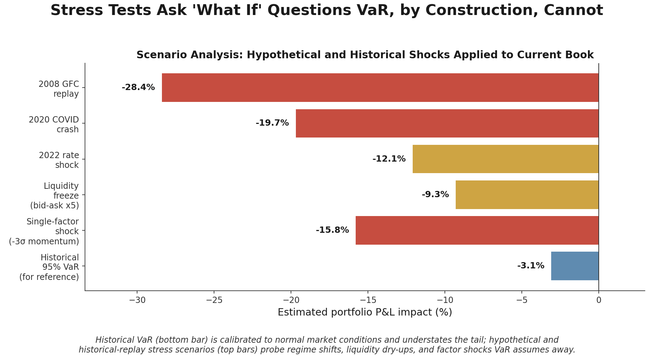
Figure 5.1 — Estimated portfolio impact under a set of historical-replay and hypothetical stress scenarios, compared against historical 95% VaR. VaR, calibrated to normal market conditions, understates the tail; the stress scenarios probe regime shifts, liquidity dry-ups, and factor shocks that VaR's statistical calibration assumes away.
Why this matters for capital allocation — A portfolio can show a comfortably small VaR figure while still being severely exposed to a scenario that has simply not occurred within the historical sample used to calibrate it. Stress testing is not a replacement for VaR and Expected Shortfall — it is the check that catches exactly the exposures those statistically-calibrated measures are structurally unable to see.

shock = {'equity_factor': -0.30, 'credit_spread_bps': +250, 'rates_bps': -100}

stressed_pnl = sum(
position.exposure_to(factor) * shock_size
for factor, shock_size in shock.items()
for position in portfolio.positions
)

5.2 Factor, Concentration, Liquidity, Leverage, Counterparty, and Model Risk
Beyond price-return volatility, a full risk picture requires naming and monitoring several further, qualitatively different sources of risk — most of which cannot be read off a return series at all:
- Factor risk — exposure to broad, systematic drivers (market beta, value, momentum, rates) that move many positions together; a portfolio can look diversified by position count while carrying almost all its risk in one or two underlying factors.
- Concentration risk — exposure unusually concentrated in a small number of positions, sectors, or factors, so that a single adverse event affects a disproportionate share of the book.
- Liquidity risk — the risk that a position cannot be exited within the required time frame, or only at a much worse price, particularly since liquidity itself tends to evaporate precisely during the market stress a portfolio most needs to exit into.
- Leverage risk — borrowed capital or derivatives exposure amplifying losses (and margin calls) beyond what the underlying capital base can absorb, turning a moderate adverse move into a forced liquidation.
- Counterparty risk — the risk that a broker, clearinghouse, or OTC counterparty fails to meet its obligations, independent of how the underlying position itself performs.
- Model risk — the risk that a pricing, risk, or trading model is wrong, miscalibrated, or applied outside the conditions it was validated under — a risk that sits underneath every other metric in this module, since each one is itself the output of a model.

Practical Exercise
Using a daily return series for a strategy or portfolio of your choice (a backtest output, or a real fund's published returns):
- Compute the equity curve, the running high-water mark, and the underwater (drawdown) curve; identify the maximum drawdown and its duration (Section 1).
- Compute the Sharpe, Sortino, and Calmar ratios, stating the annualisation convention used for each, and note the sample length behind them (Section 2).
- If trade-level data is available, compute profit factor, win rate, and expectancy, and confirm whether win rate alone would have given a misleading impression of profitability (Section 3).
- Compute historical VaR and Expected Shortfall at the 95% confidence level, and discuss concretely what each metric does and does not tell you about the tail (Section 4).
- Apply at least one hypothetical stress scenario (e.g., a market-wide 3-standard-deviation move) to the same portfolio and compare the resulting estimated loss to the historical VaR figure (Section 5).
import numpy as np, pandas as pd

equity = 100 * (1 + returns).cumprod()
drawdown = (equity - equity.cummax()) / equity.cummax()
max_dd, dd_duration = drawdown.min(), (drawdown < 0).astype(int).groupby(
(drawdown >= 0).cumsum()).sum().max()

sharpe = returns.mean() / returns.std(ddof=1) * np.sqrt(252)
downside = returns[returns < 0]
sortino = returns.mean() / np.sqrt((downside ** 2).mean()) * np.sqrt(252)
ann_return = (1 + returns).prod() ** (252 / len(returns)) - 1
calmar = ann_return / abs(max_dd)

var_95 = -np.percentile(returns, 5)
es_95 = -returns[returns <= -var_95].mean()

Common Beginner Mistakes
Common mistake — Reporting Sharpe ratio without annualisation convention stated. A Sharpe ratio of 1.2 means something different depending on whether it was annualized from daily, weekly, or monthly returns, and by which √(periods per year) factor. Two Sharpe ratios quoted without their annualisation convention (or their sample length, per Section 2.1's callout) are not safely comparable, however similar the two numbers look.

Common mistake — Treating VaR as a worst-case loss. As Section 4.1 covers, VaR is a threshold that losses exceed with a known, non-zero probability — not a bound on the worst possible outcome. Expected Shortfall (Section 4.2) is the metric that actually captures the tail beyond the VaR threshold, and is the appropriate complement wherever VaR is being used to reason about capital adequacy.

Advanced Extensions
Extreme Value Theory (EVT) models the tail of a loss distribution directly, using only the most extreme observations rather than the full data set, and provides a more principled basis for estimating VaR and Expected Shortfall far out in the tail than simply reading a high percentile off a limited historical sample. Copula-based tail-risk modelling extends this idea to multiple assets or risk factors jointly, capturing the fact that tail dependence between assets (how likely they are to crash together) is often much stronger than their ordinary, day-to-day correlation would suggest — exactly the kind of behaviour that makes diversification appear to fail precisely when it is needed most. Both are deferred to full treatment at Level 5 of the curriculum: the metrics in this module need to be second nature first, since EVT and copula methods are refinements of the same VaR/Expected Shortfall concepts introduced in Part 4, not replacements for understanding what those concepts mean.

Professional Applications
- Capital allocation — risk-adjusted return ratios (Section 2) are a standard input to how capital is divided across strategies or desks, since raw return alone rewards risk-taking without regard for whether that risk was compensated.
- Risk limits — VaR and Expected Shortfall (Section 4) are used to set and monitor real-time position and desk-level risk limits, with breaches typically triggering an automatic reduction in exposure.
- Strategy comparison and due diligence — the full suite of metrics in this module (drawdown, risk-adjusted ratios, trade statistics, tail-risk measures) forms the standard due-diligence checklist allocators and risk committees use to compare candidate strategies or funds before committing capital.

Where to Go Next
This module gives you the vocabulary and the caveats — drawdown, risk-adjusted ratios, trade statistics, VaR, Expected Shortfall, and the broader taxonomy of portfolio risk — that determine whether a strategy's numbers can be trusted at face value or need to be interrogated further. Nearly every capital-allocation or risk-management decision later in the curriculum assumes these metrics, and their common misinterpretations, are already second nature.

Suggested paths depending on your focus
- Heading into research: revisit any backtest results you have already produced and recompute their Sharpe ratios with explicit sample-size caveats attached, rather than quoting a single point estimate as if it were exact.
- Heading into development: centralise risk-metric calculation into a single, tested utility library, so that annualisation conventions and drawdown definitions cannot silently diverge across notebooks or teams.
- Heading into trading: build live monitoring for VaR and Expected Shortfall breaches directly into position-management tooling, so a risk-limit breach is flagged automatically rather than discovered after the fact.

